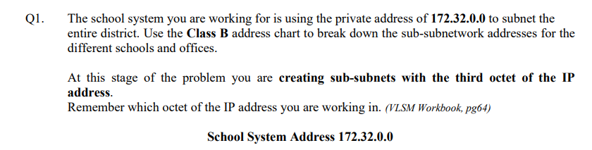

| **Number of Host needed** | **Subnet Address** | **Prefix/CIDR** | **Broadcast** |
| --- | --- | --- | --- |
| 2400 | 172.32.0.0 | /20 | 172.32.15.255 |
| 2000 | 172.32.16.0 | /21 | 172.32.23.255 |
| 1200 | 172.32.24.0 | /21 | 172.32.31.255 |
| 1000 | 172.32.32.0 | /22 | 172.32.35.255 |
| 550 | 172.32.36.0 | /22 | 172.32.39.255 |
| 475 | 172.32.40.0 | /23 | 172.32.41.255 |
| 450 | 172.32.42.0 | /23 | 172.32.43.255 |
| 400 | 172.32.44.0 | /23 | 172.32.45.255 |
| 300 | 172.32.46.0 | /23 | 172.32.47.255 |